Paul Buske

CSCI 3350-W01

Final Project Part 1

Website Title: Paul’s Construction Solutions (PCS)

The website targets perspective customers who want to build with Paul’s Construction Solutions. The intent of the website is to offer a platform that allows the customer to get a feel for the Clarksville area by highlighting different places like the Roxy and Dunbar cave. The website will also feature links to information about the local schools around the neighborhood.

The neighborhood link to the website will include floor plans, estimated pricing, and amenities like the community pool and golf course. It will feature the benefits of building with Paul’s Construction Solutions including an unmatched full two-year warranty. The website will also have a way for people to file claims for warranty repairs.

Target audience: Homebuyers that can afford homes starting in the low $200,000s.

Sections:

1. Landing Page
   1. Header (from left to right)
      1. Logo
      2. Nav Bar
         1. Remodels
         2. Floor Plans
         3. Loan Calculator
         4. Build Process
         5. Contact Us
      3. File a Warranty Claim Button
   2. About us section
      1. Background is the Clarksville Pride Picture
      2. Brief description of the company.
   3. About Clarksville section
      1. Button one
         1. Background is the Roxy image.
         2. Button text: Downtown Clarksville
      2. Button two
         1. The background is the Dunbar Cave image.
         2. Button text: Surrounding Clarksville.
   4. Neighborhood section Carousel
      1. Image one with button Community pool photo
      2. Image two with button Golf course photo
      3. Image three button School photo
   5. Build Process
      1. Carousel that talks about the build process.
         1. Photo one architect
         2. Photo two hard hat
         3. Photo three neighborhood construction
   6. Contact us section.
      1. Background is the buying a home photo.
      2. Button text: Start building!

Visual Research Site 1 uses flex box for responsive design: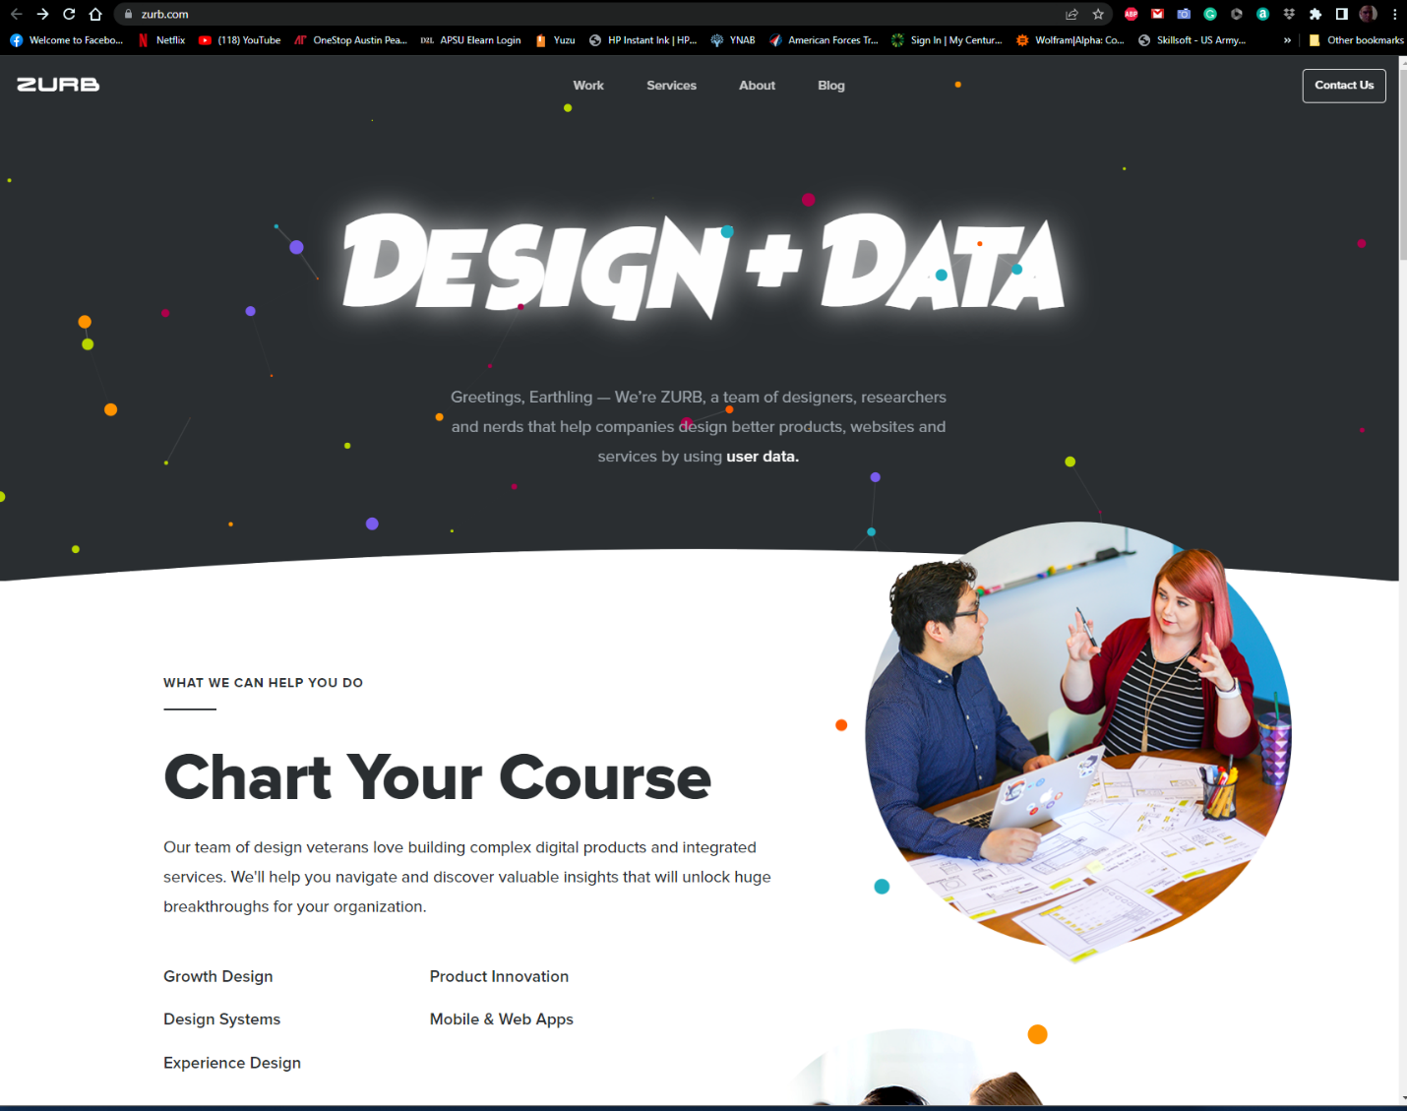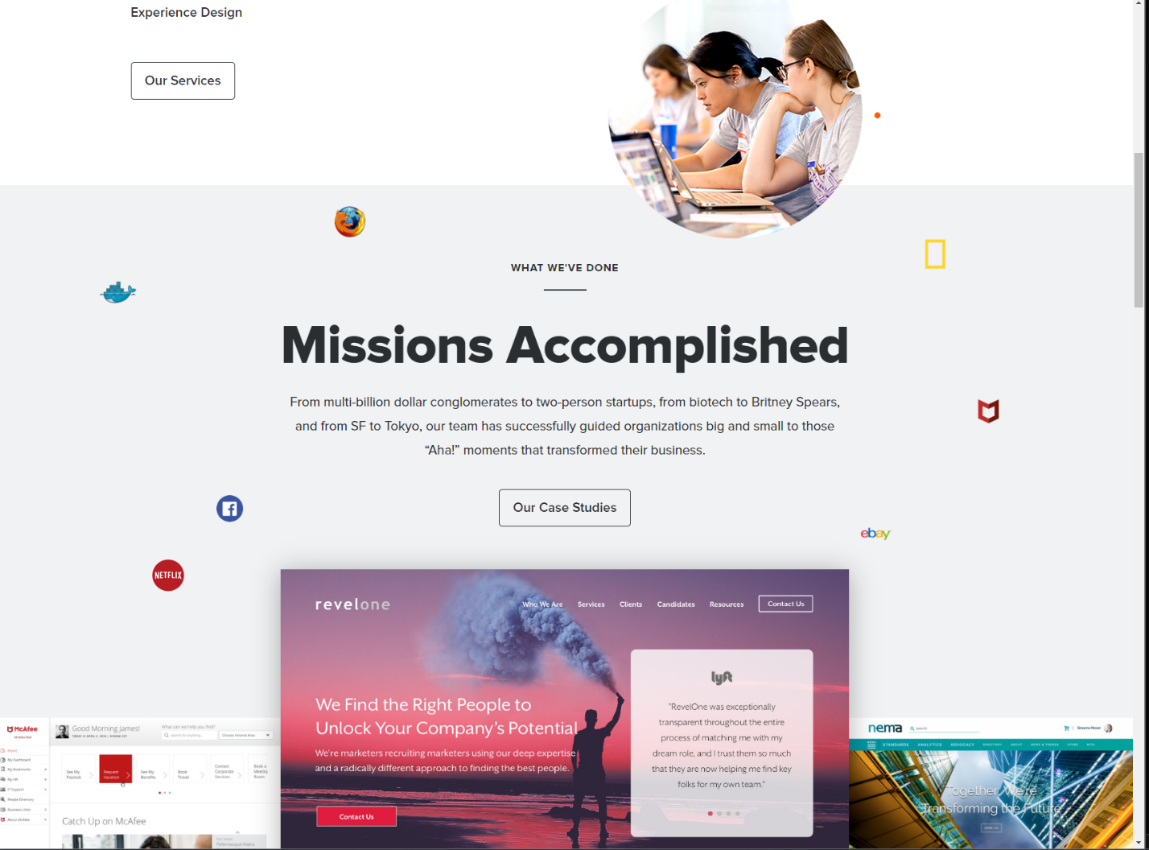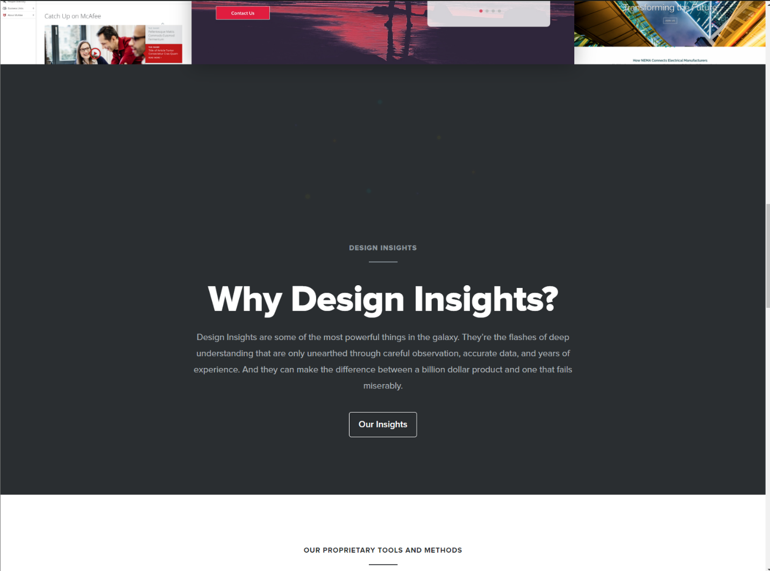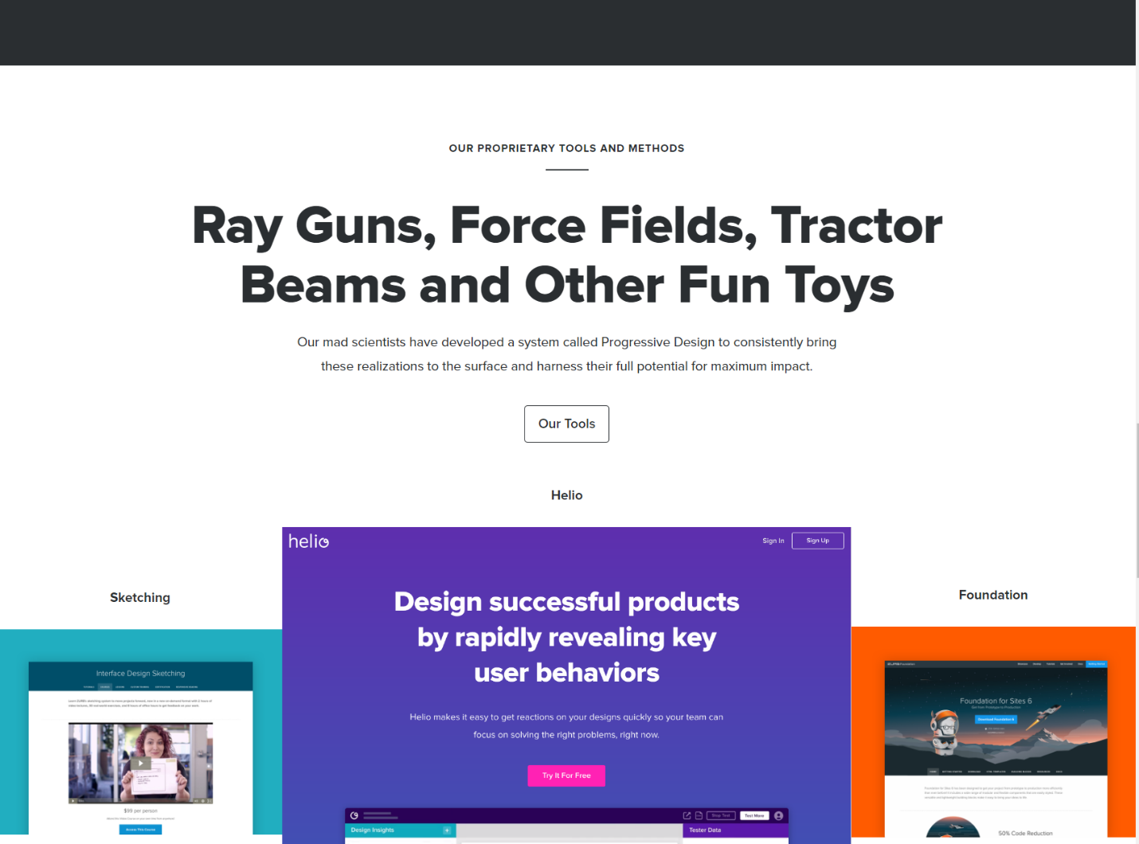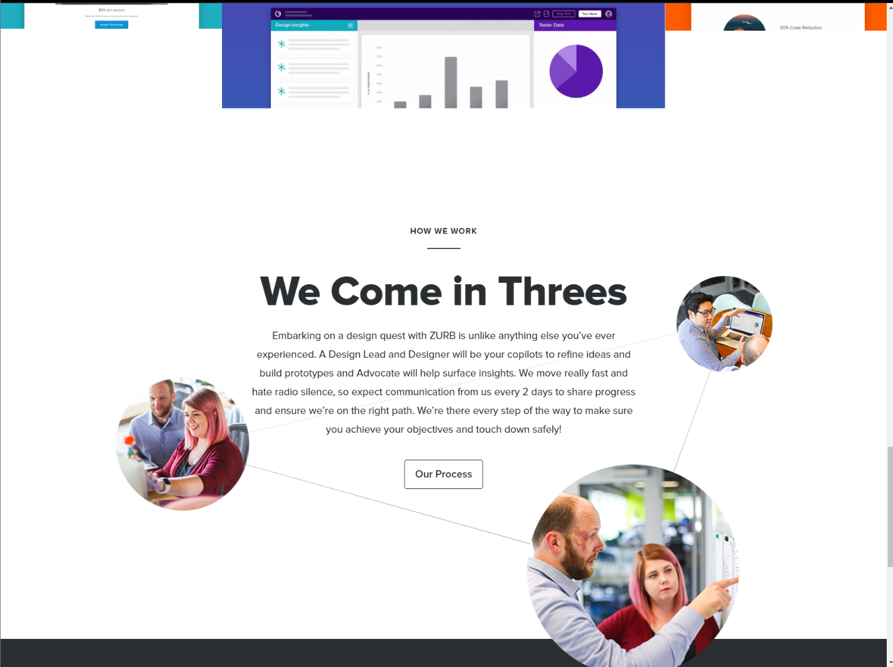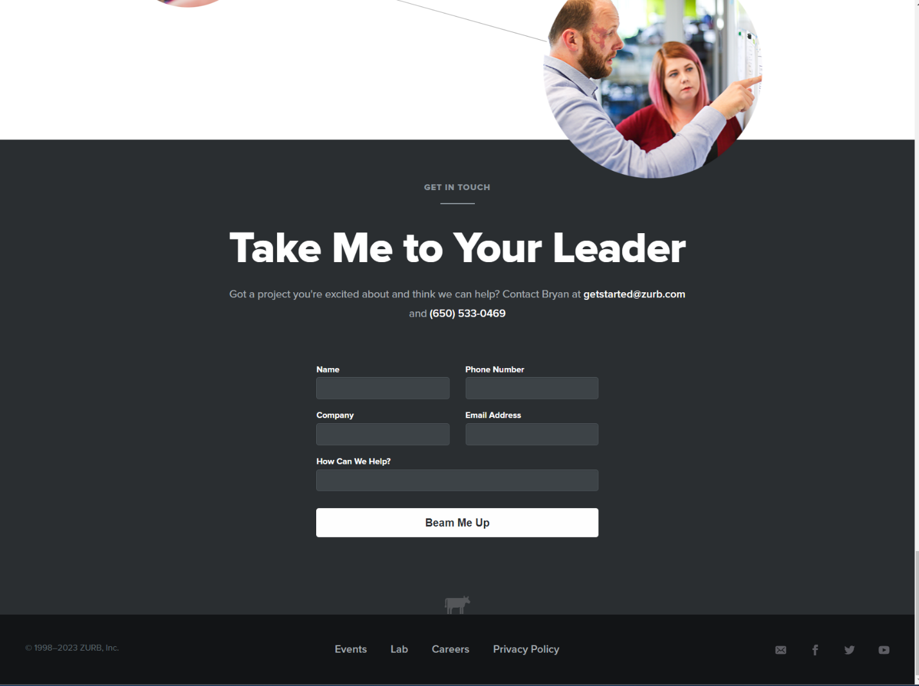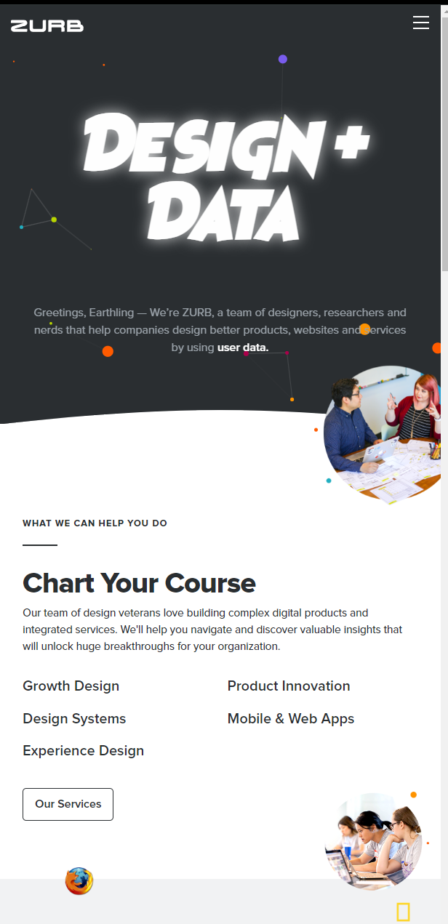

Visual Research Site 2 uses flex box for responsive design: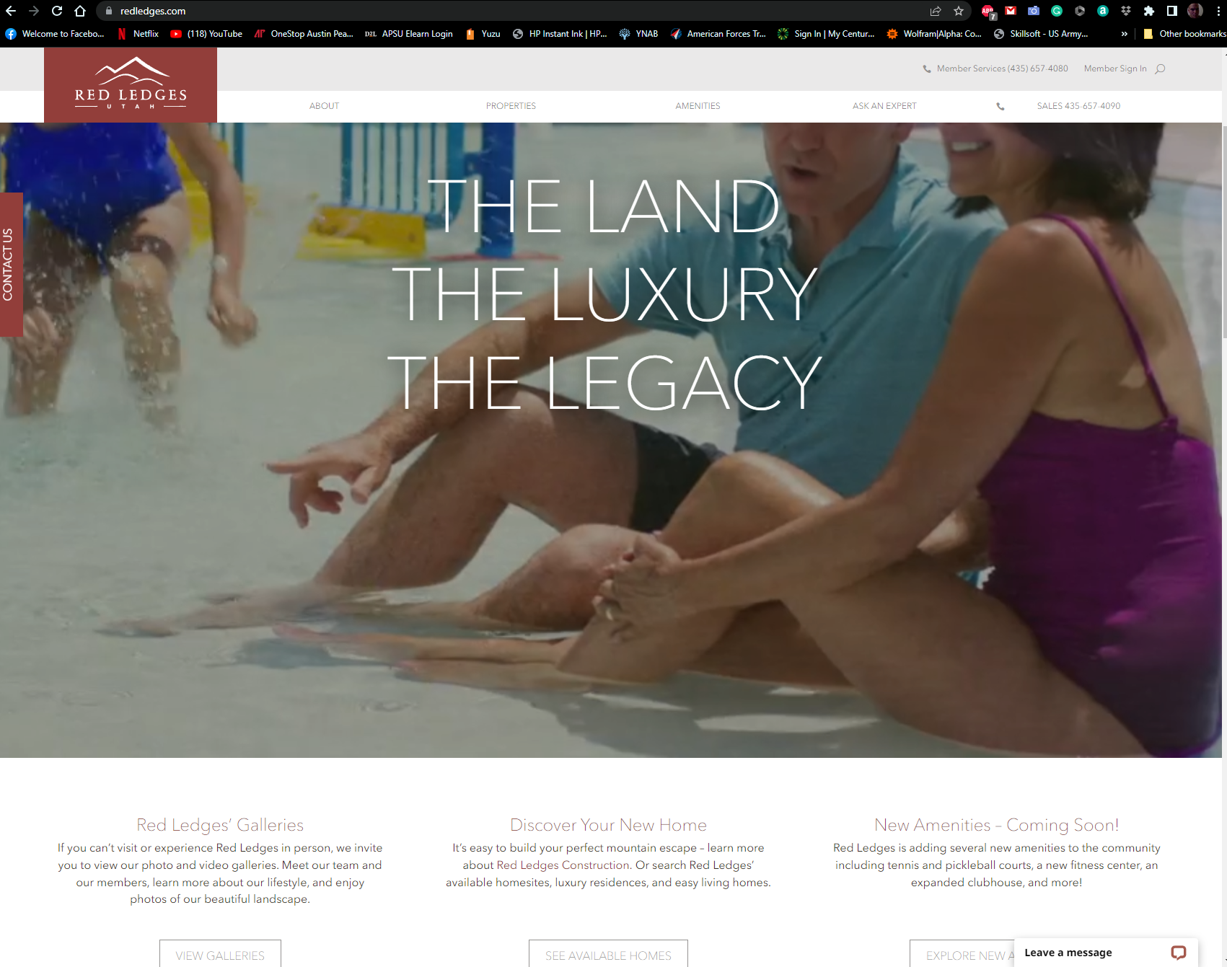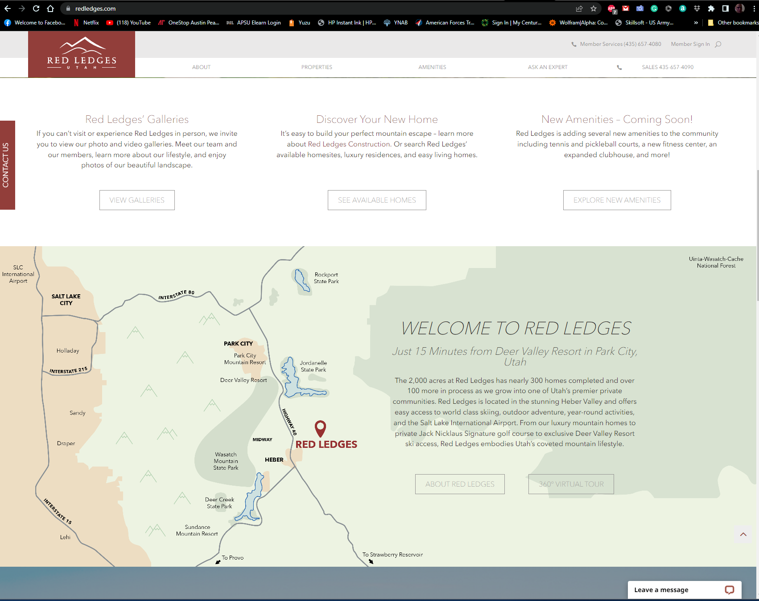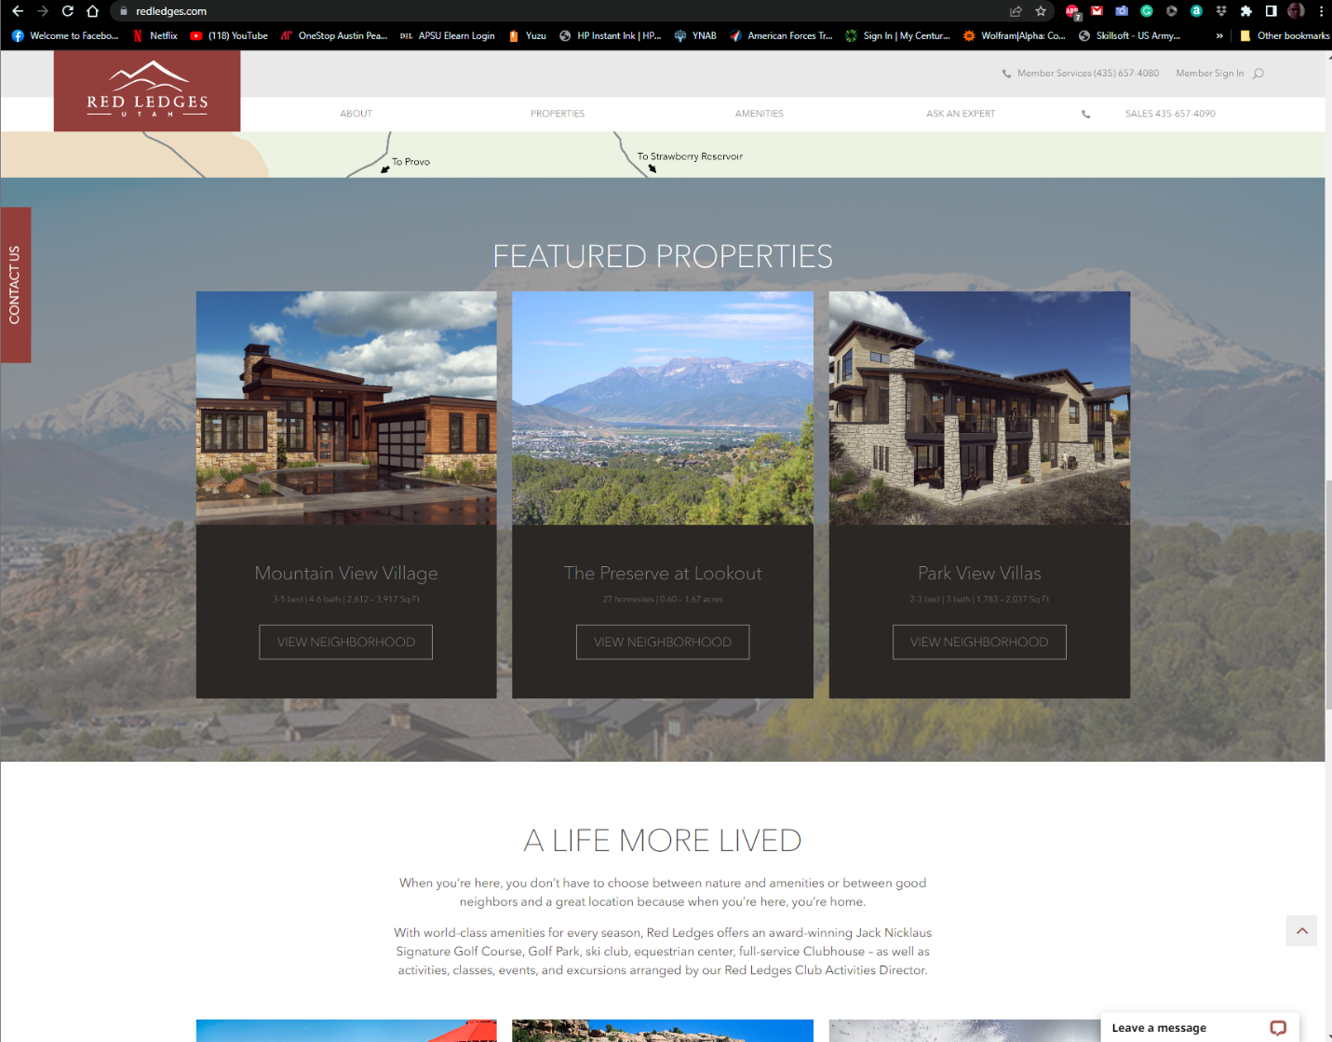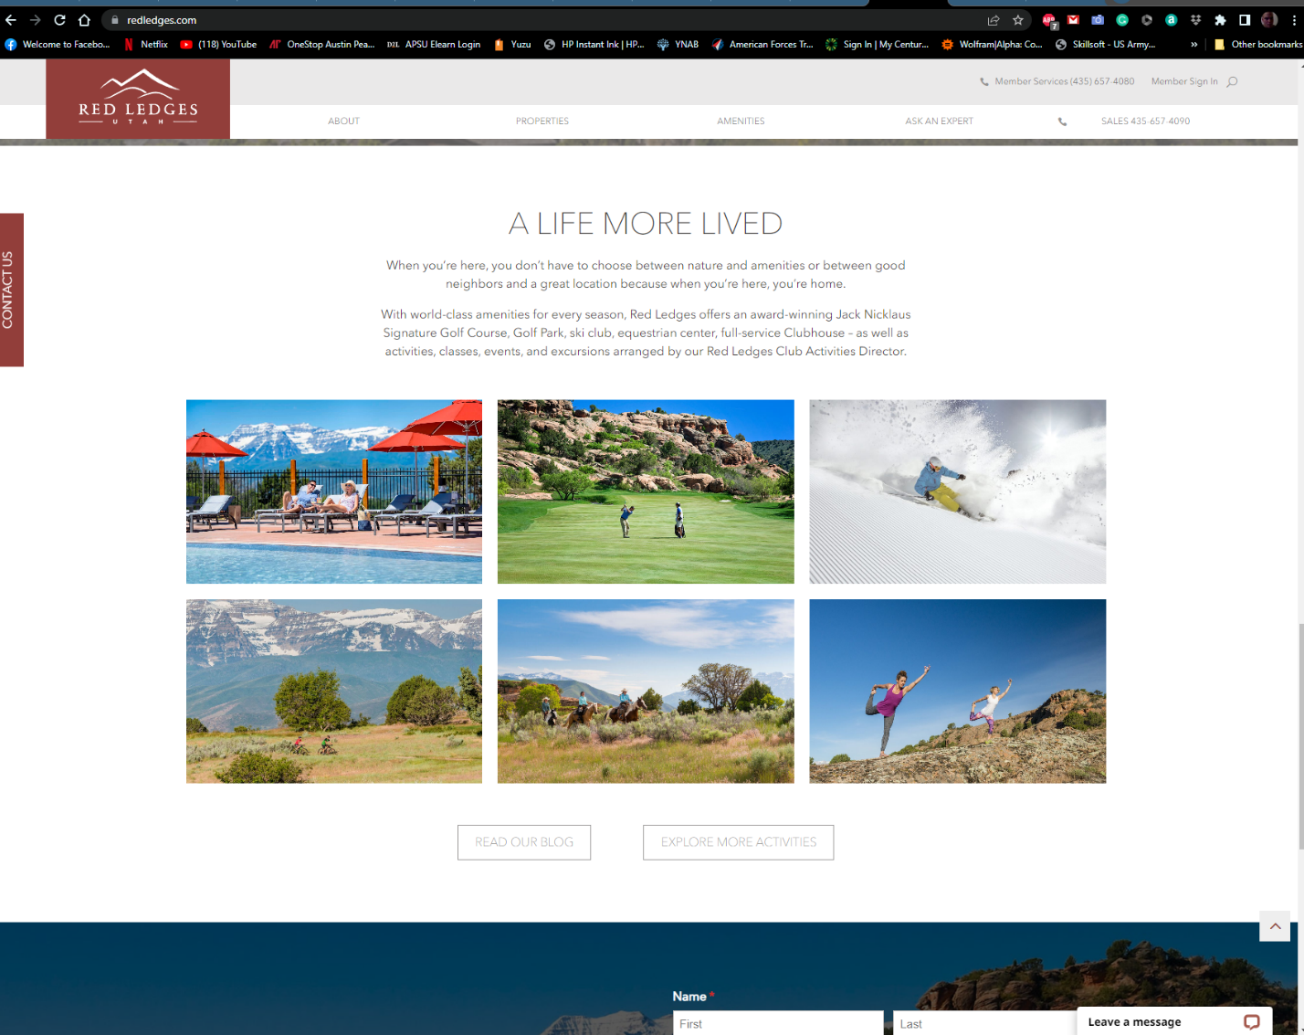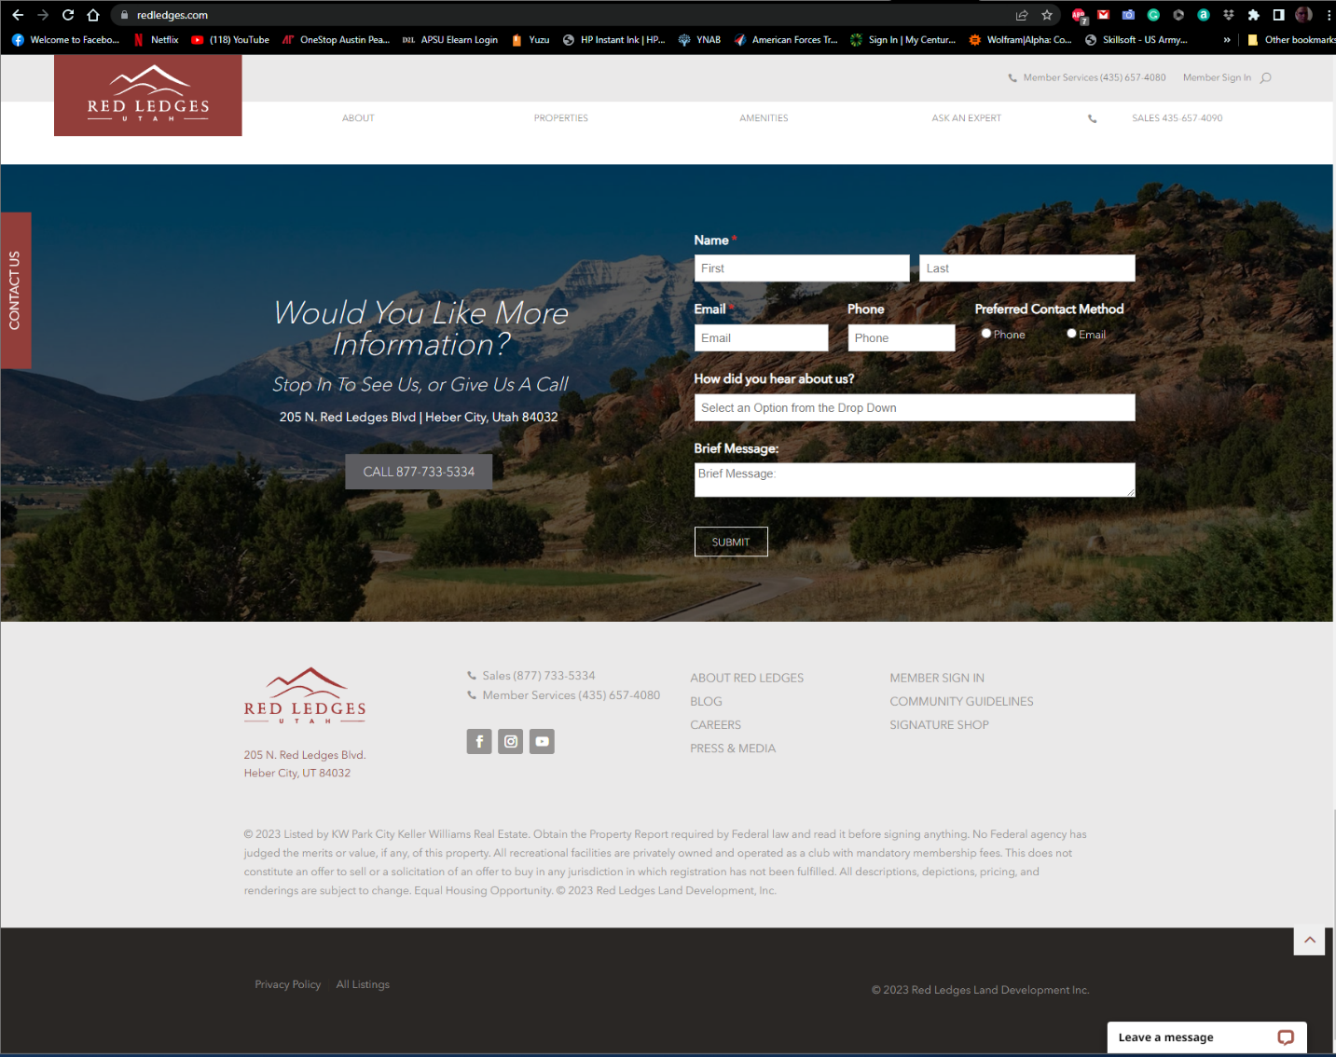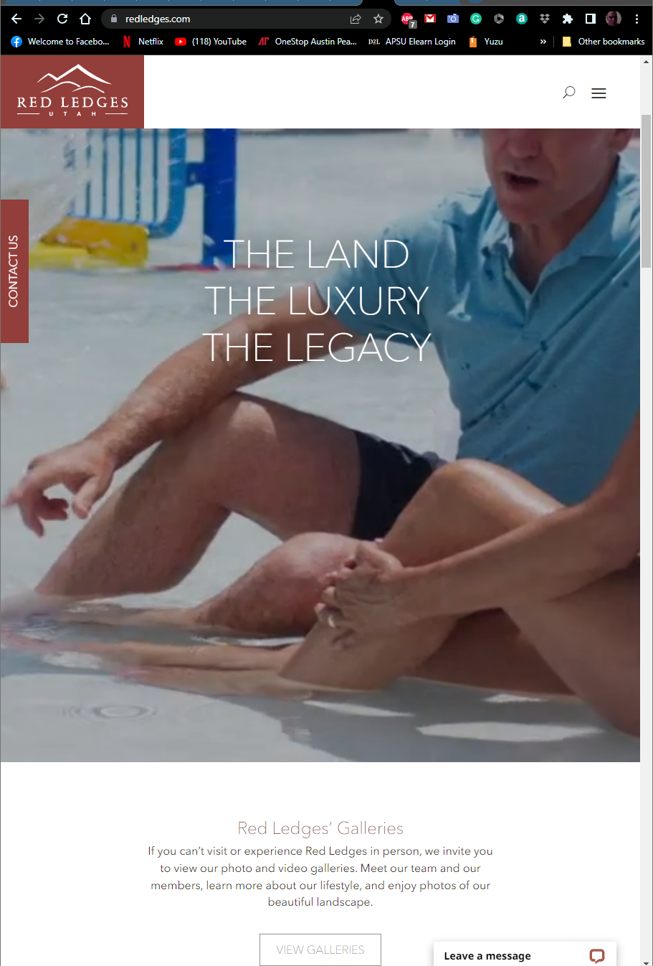

Visual Research Site 3 uses flex box for responsive design: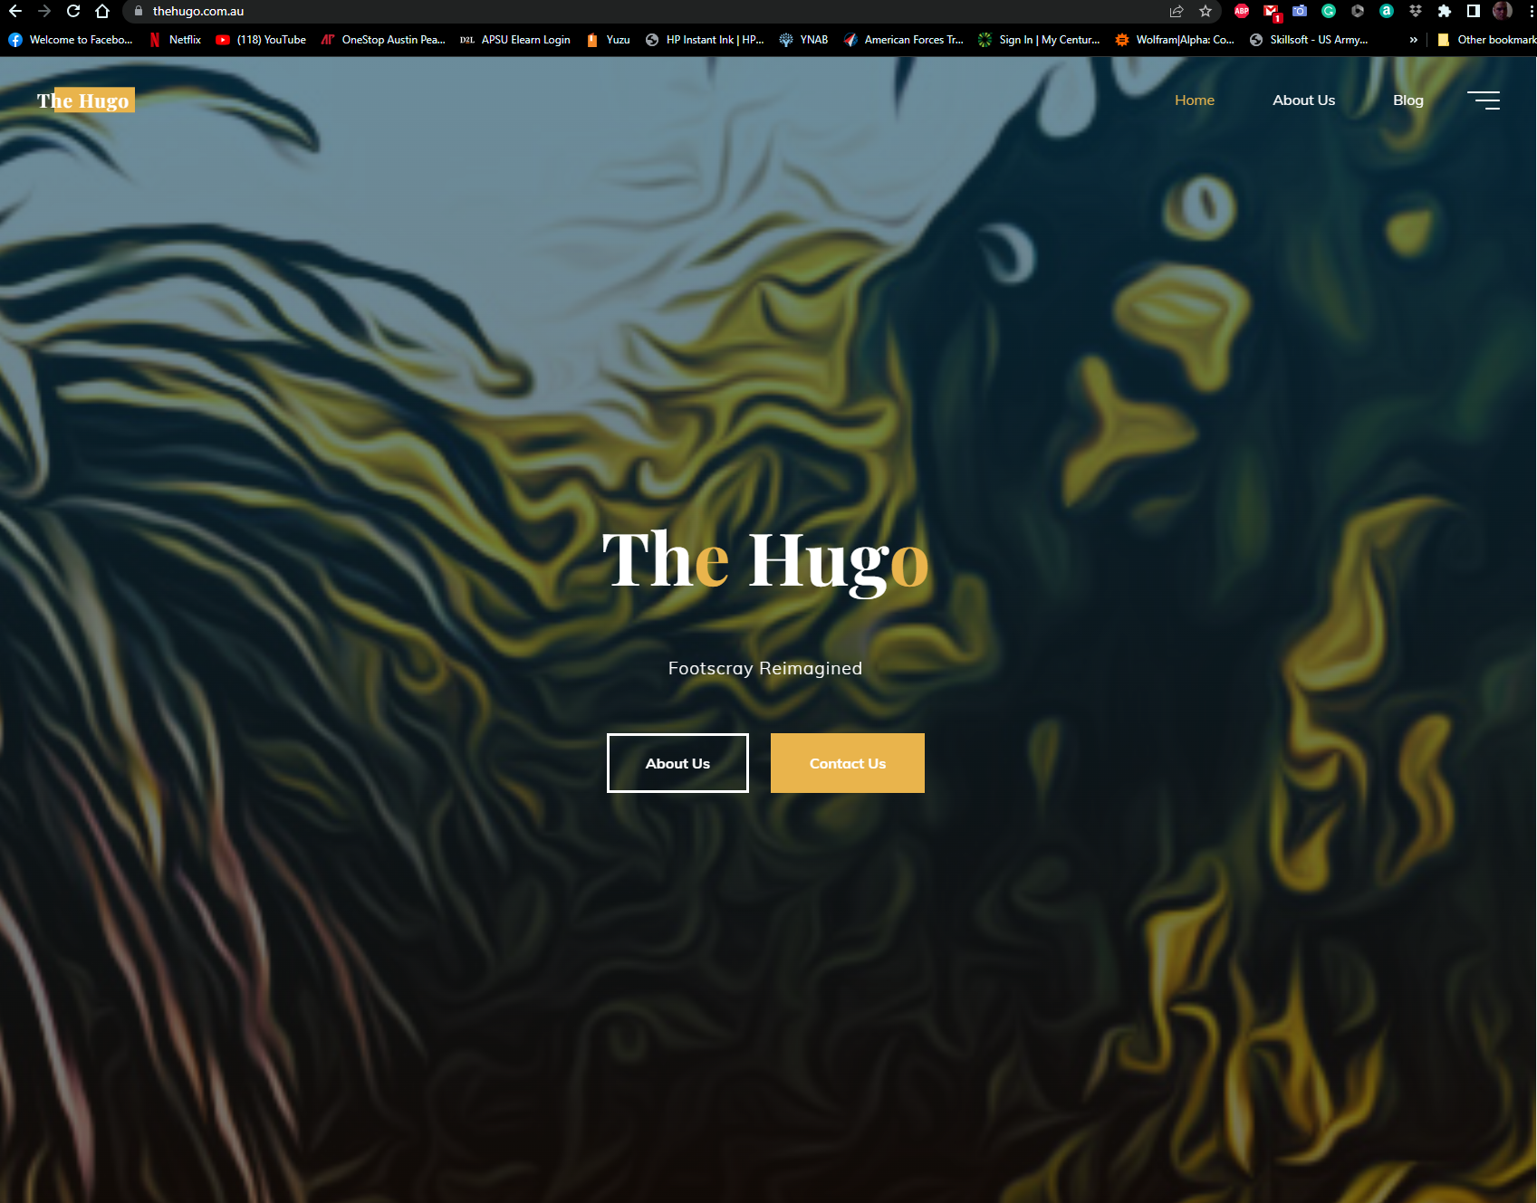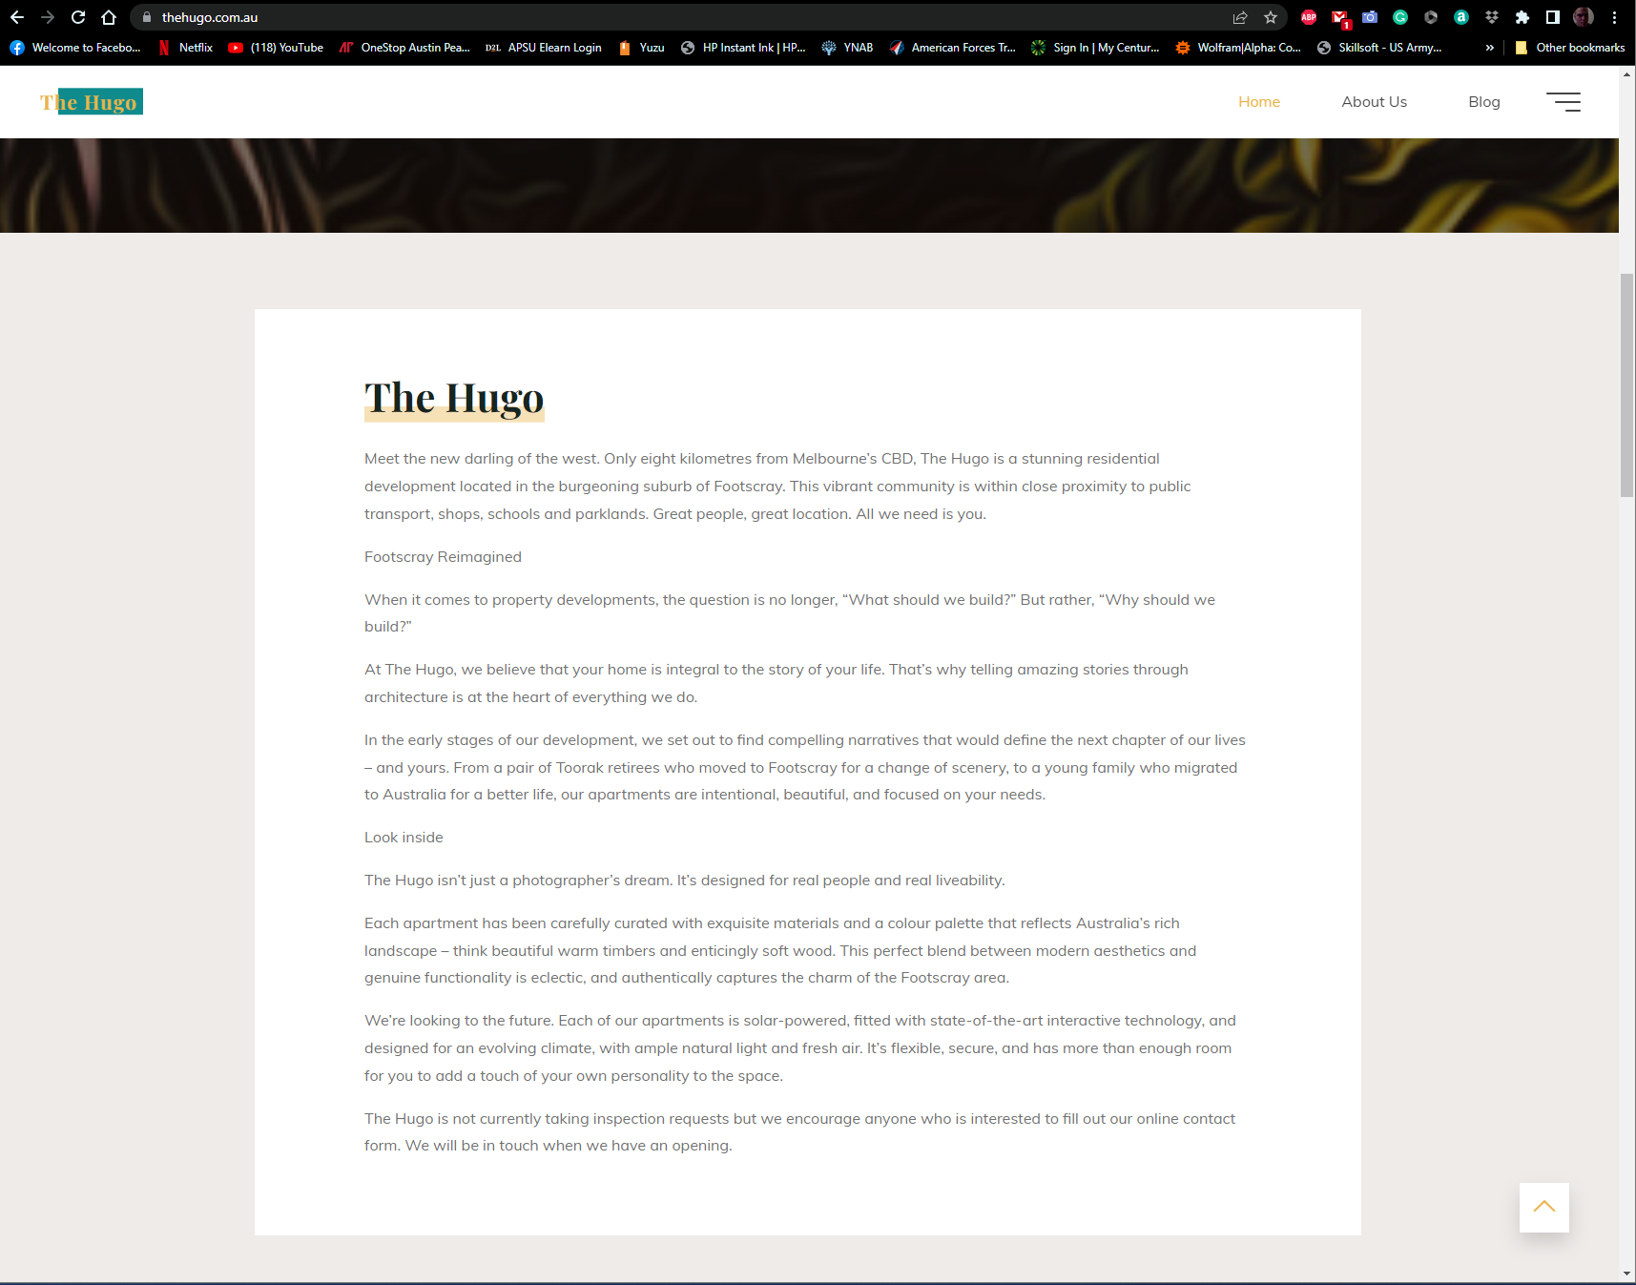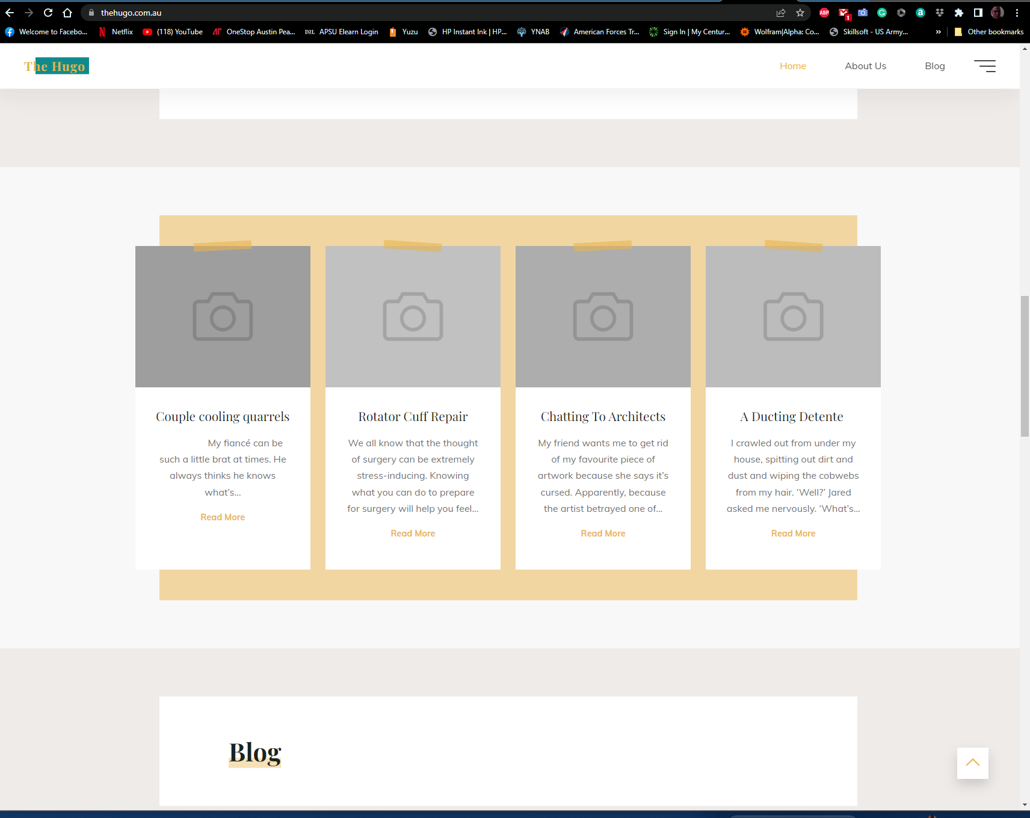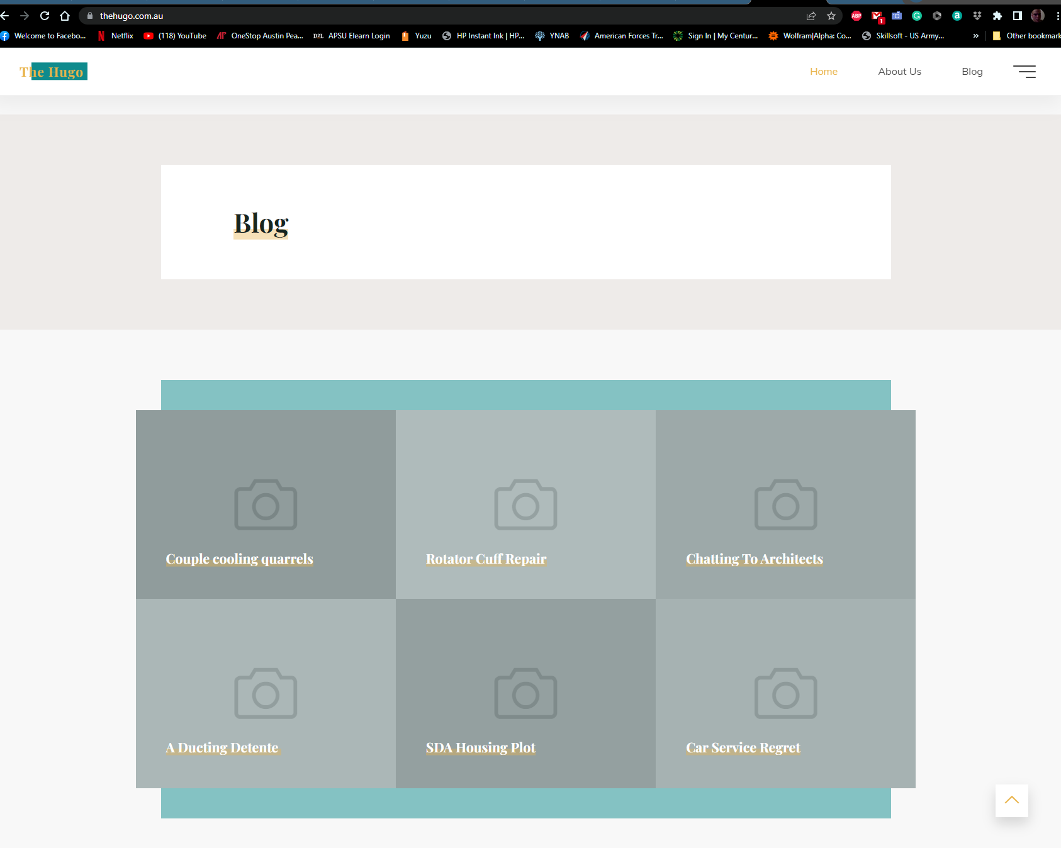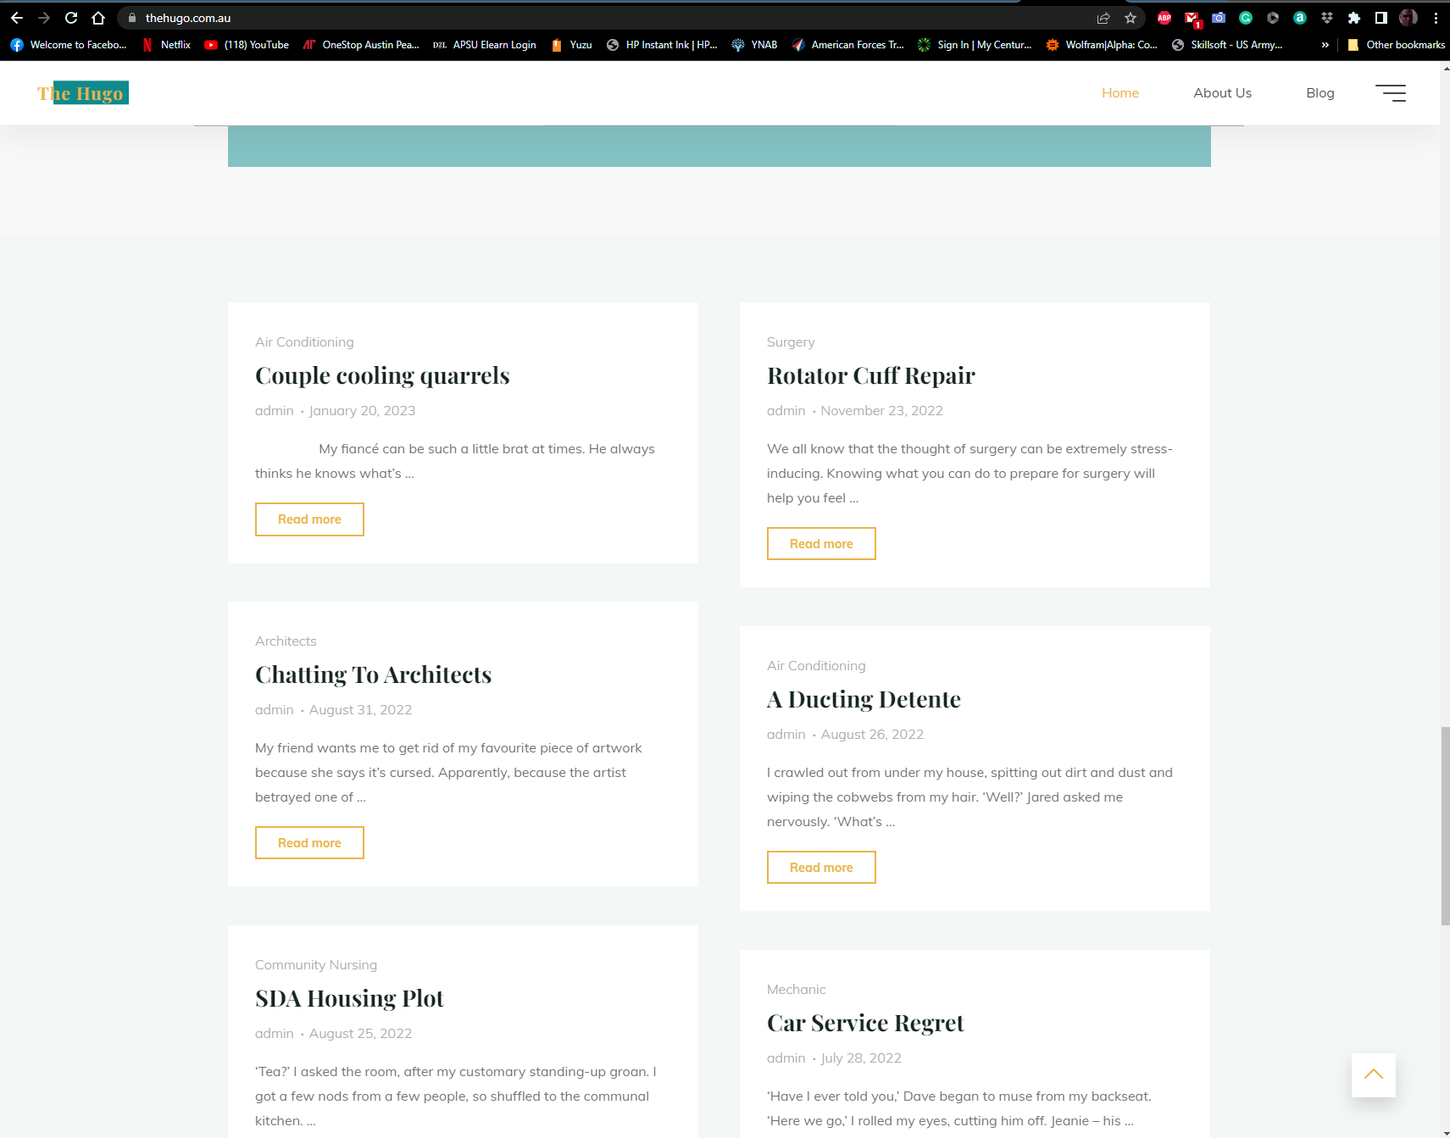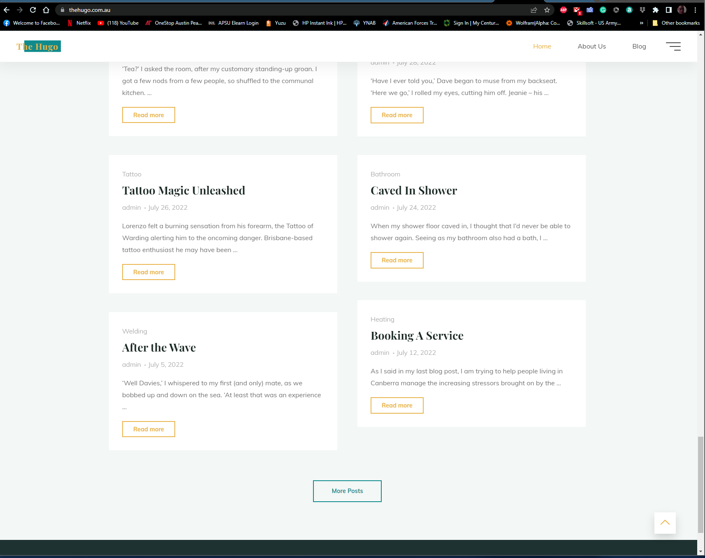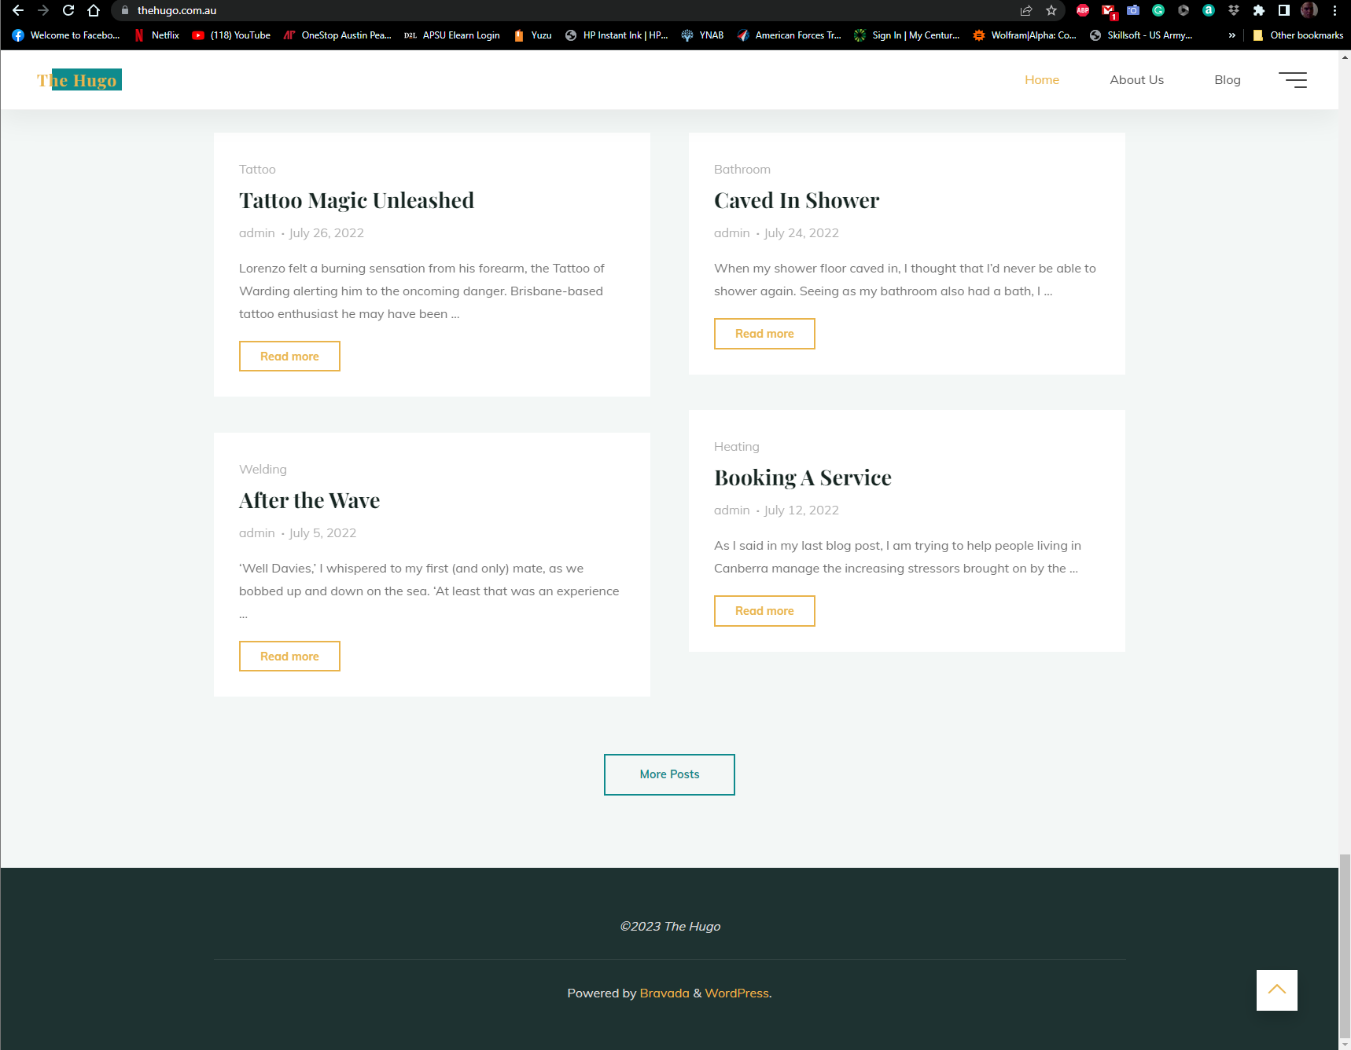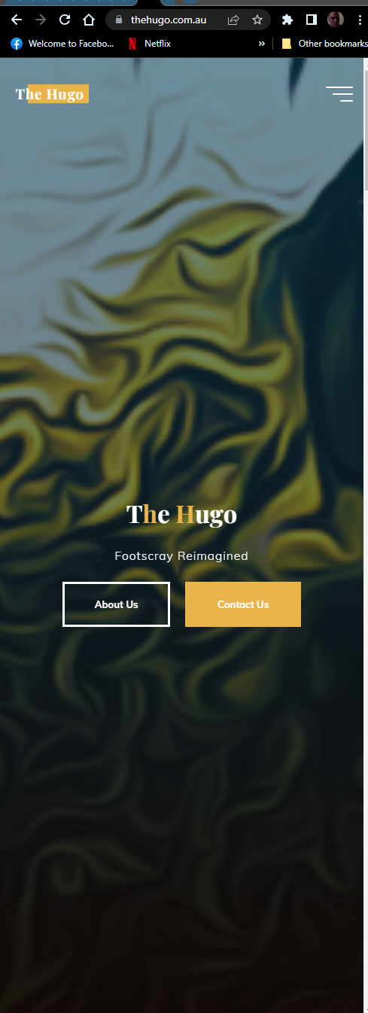

Visual Research Site 4 uses flex box for responsive design: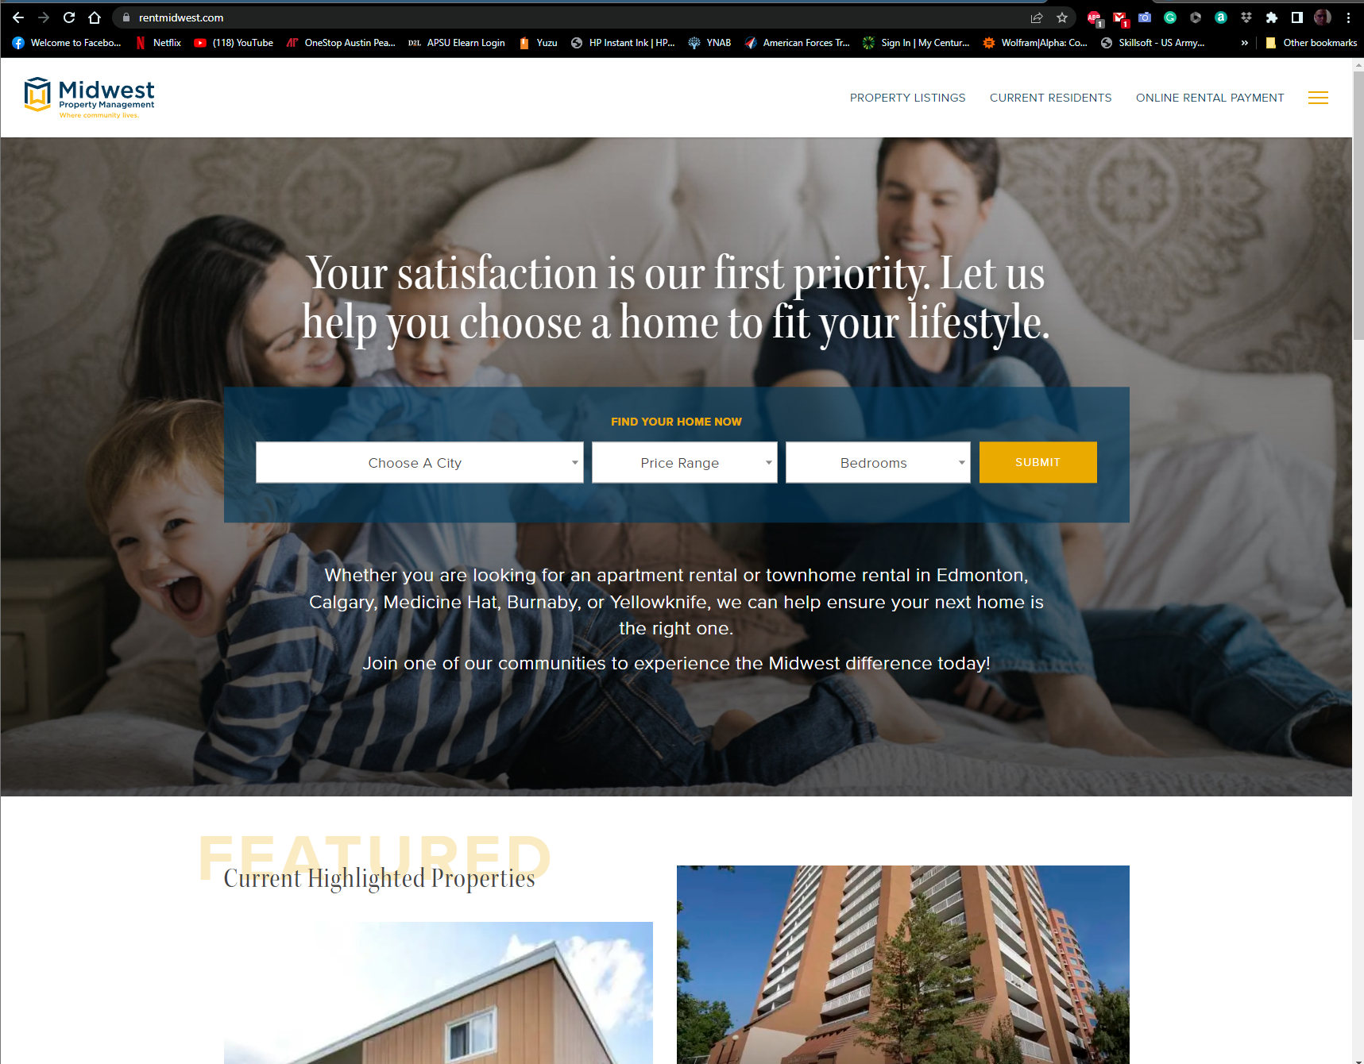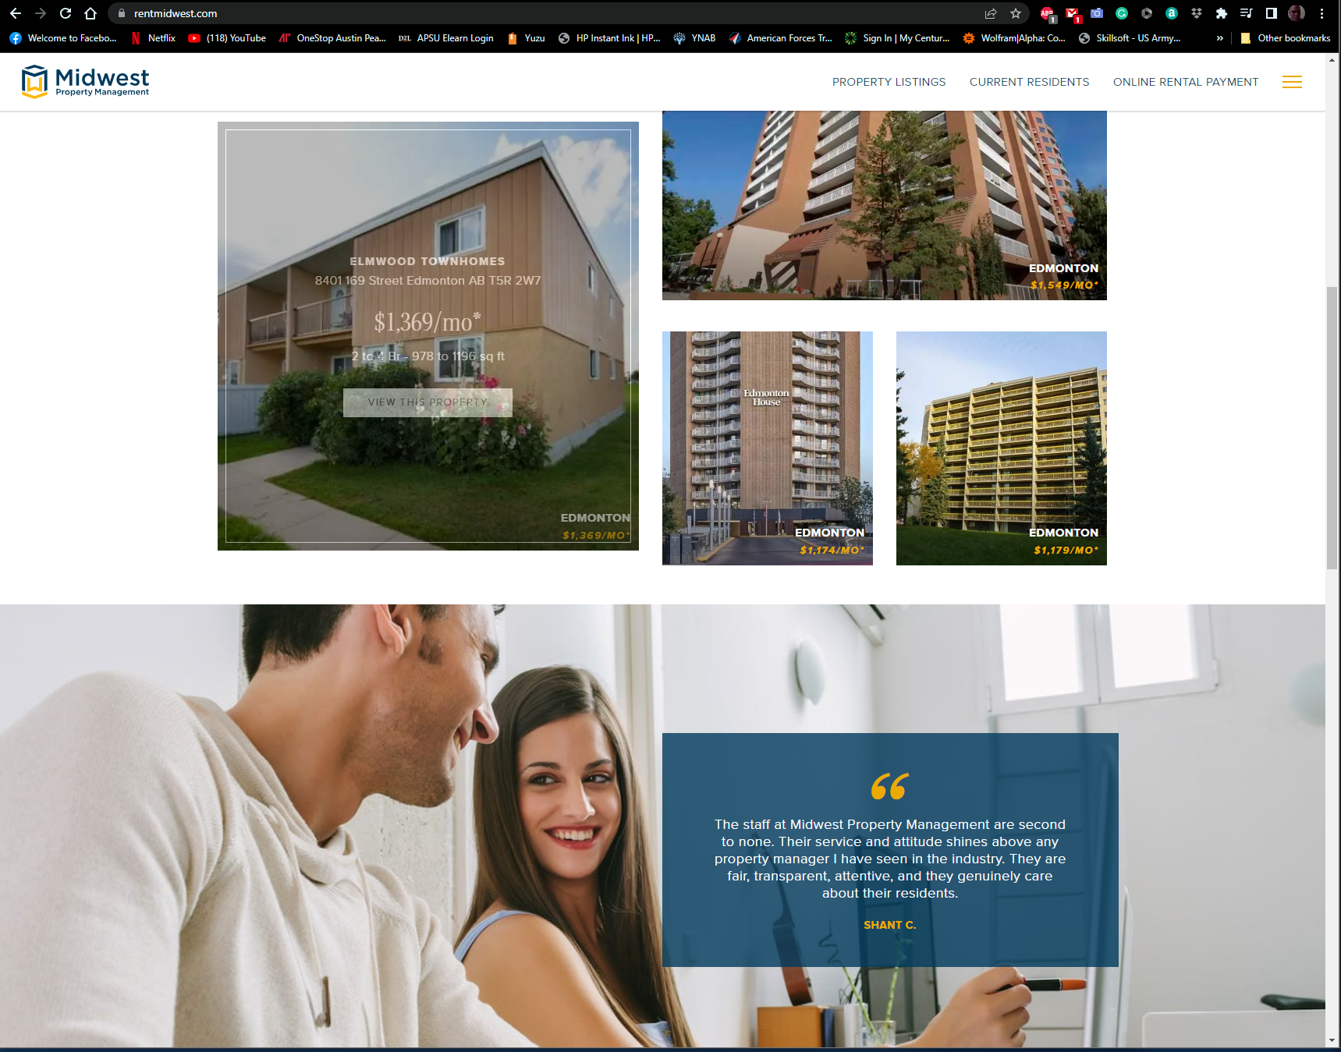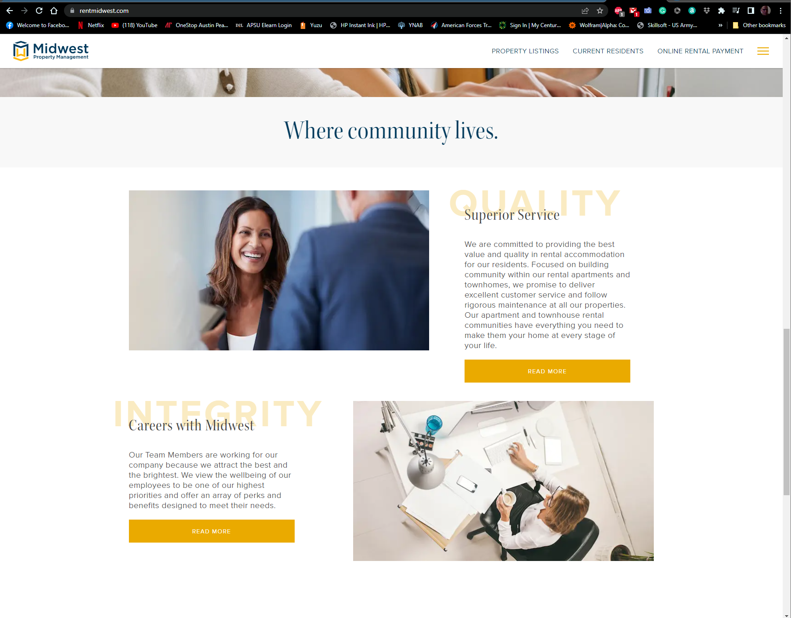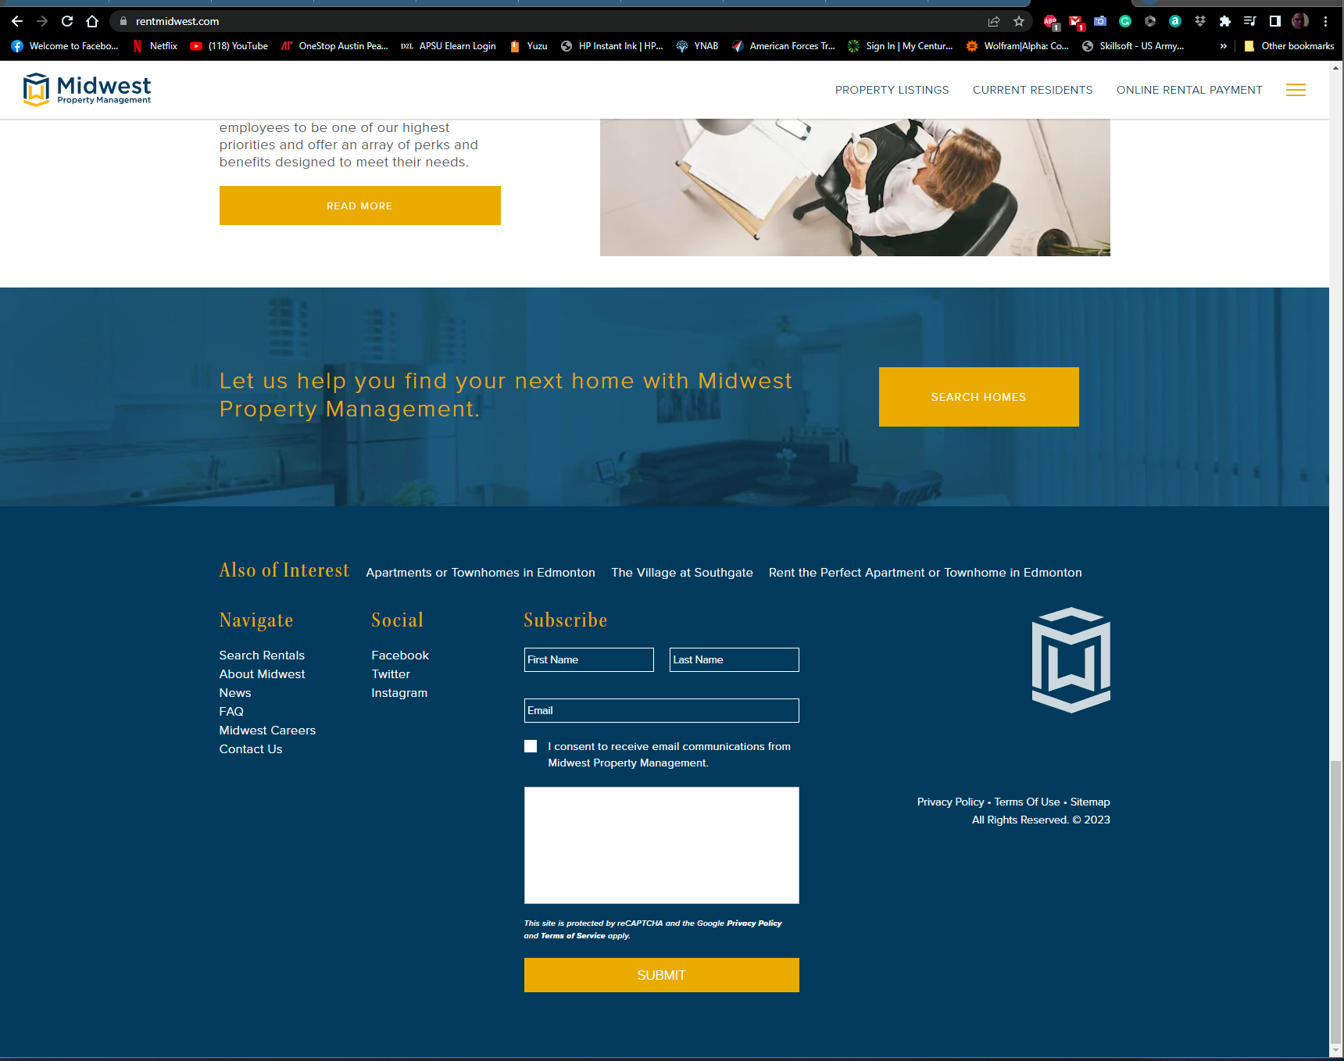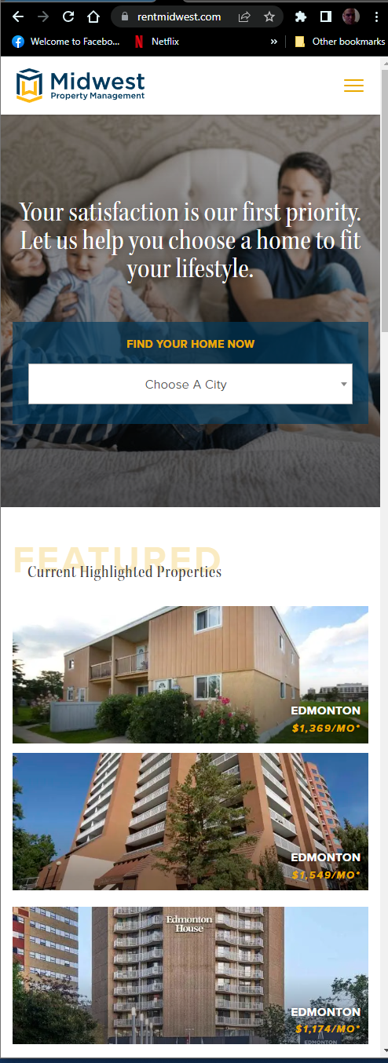

Color Pallet:

